- Domain password valid for only one month after password will expire. Change password
- If password Expire follow this steps only
Domain Attached Systems(BSNL LINE)
Press Ctl -Alt –Delete
Figure-1
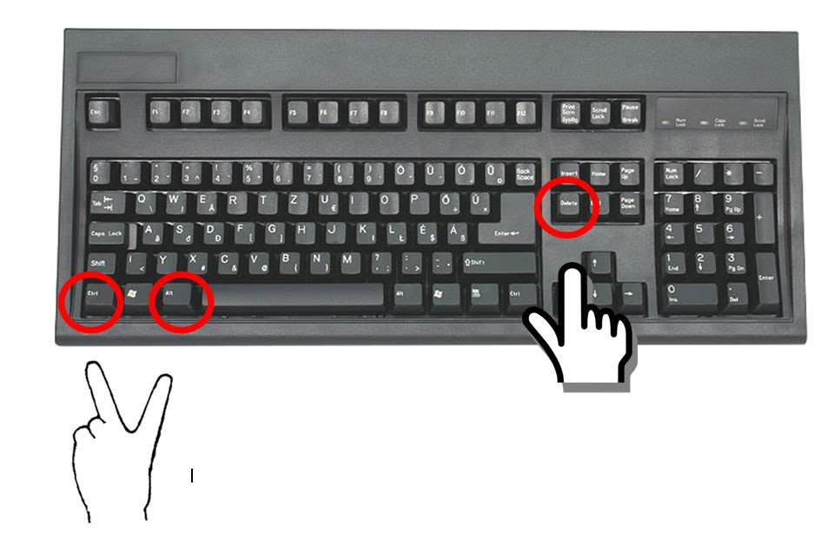
Figure-2
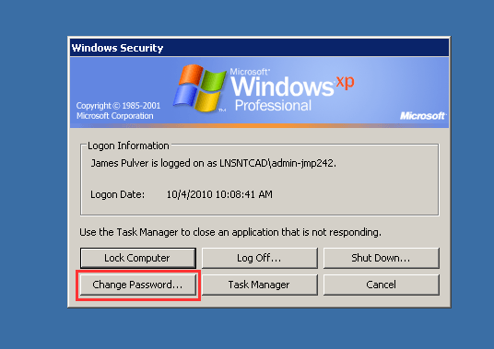

Figure-3

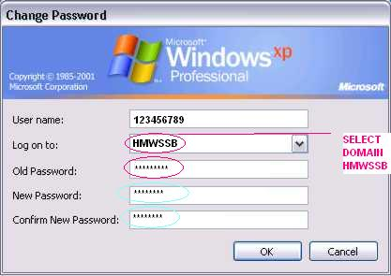
Click ok
Change your password successfully Alret Message Come.

2.Tata photon Connected Systems Chang password
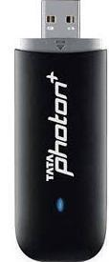
Go start > Run - Enter mstsc - Enter ip 10.230.2.130 -Click Connect - Enter User name – Password
Ask password change then change your password
Figure-1
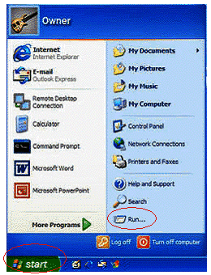 click Run
Figure-2
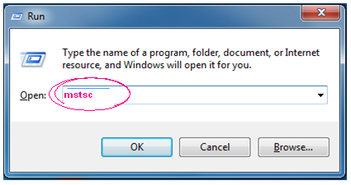
Enter mstsc then press ok
Open remote Desktop
Enter 10.230.2.130
Click connect
Figure-3
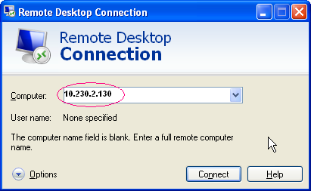
Click connect
Figure-4
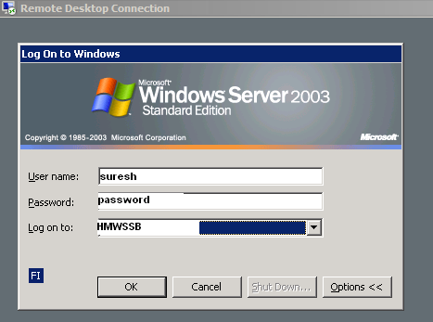
Then ask password change your password
If Any problems call Edp

